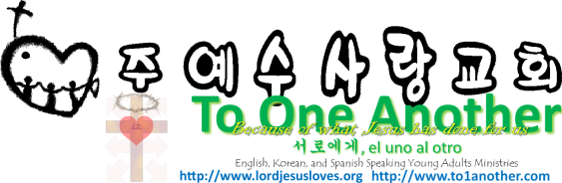
The Accomplishment of the New Covenant
Pastor Yoo Nam Kang
Hebrews 9:15
October 28, 2012
Scriptures in New Living Translation

Hebrews 9:15
That is why he is the one who mediates a new covenant between God and people, so that all who are called can receive the eternal inheritance God has promised them. For Christ died to set them free from the penalty of the sins they had committed under that first covenant.
Deuteronomy 30:6
“The Lord your God will change your heart and the hearts of all your descendants, so that you will love him with all your heart and soul and so you may live!

- How was the new covenant accomplished?
Hebrews 7:28
The law appointed high priests who were limited by human weakness. But after the law was given, God appointed his Son with an oath, and his Son has been made the perfect High Priest forever.
Hebrews 9:15
That is why he is the one who mediates a new covenant between God and people, so that all who are called can receive the eternal inheritance God has promised them. For Christ died to set them free from the penalty of the sins they had committed under that first covenant.
John 1:29
The next day John saw Jesus coming toward him and said, “Look! The Lamb of God who takes away the sin of the world!

- He came as the mediator of the New Covenant
John 3:3, 5
3 Jesus replied, “I tell you the truth, unless you are born again, you cannot see the Kingdom of God.” 5 Jesus replied, “I assure you, no one can enter the Kingdom of God without being born of water and the Spirit.
John 1:12
But to all who believed him and accepted him, he gave the right to become children of God.
James 1:18
He chose to give birth to us by giving us his true word. And we, out of all creation, became his prized possession.
1John 5:11-12
11 And this is what God has testified: He has given us eternal life, and this life is in his Son. 12 Whoever has the Son has life; whoever does not have God’s Son does not have life.
1Corinthians 12:3
So I want you to know that no one speaking by the Spirit of God will curse Jesus, and no one can say Jesus is Lord, except by the Holy Spirit.
2Corinthians 3:18
So all of us who have had that veil removed can see and reflect the glory of the Lord. And the Lord—who is the Spirit—makes us more and more like him as we are changed into his glorious image.
John 5:24-25
24 “I tell you the truth, those who listen to my message and believe in God who sent me have eternal life. They will never be condemned for their sins, but they have already passed from death into life. 25 “And I assure you that the time is coming, indeed it’s here now, when the dead will hear my voice—the voice of the Son of God. And those who listen will live.

- Blessings of lives where the New Covenant has been accomplished
2Corinthians 4:16-18
16 That is why we never give up. Though our bodies are dying, our spirits are being renewed every day. 17 For our present troubles are small and won’t last very long. Yet they produce for us a glory that vastly outweighs them and will last forever! 18 So we don’t look at the troubles we can see now; rather, we fix our gaze on things that cannot be seen. For the things we see now will soon be gone, but the things we cannot see will last forever.
2Corinthians 4:3-4
3 If the Good News we preach is hidden behind a veil, it is hidden only from people who are perishing. 4 Satan, who is the god of this world, has blinded the minds of those who don’t believe. They are unable to see the glorious light of the Good News. They don’t understand this message about the glory of Christ, who is the exact likeness of God.

